**TOOLS Guide**



**Introduction**

This guide deals with the TOOL component - which enables expanding the capabilities of models and agents by performing external operations. The TOOL component allows access to additional functions and services, such as sending requests to websites, performing mathematical calculations, or accessing information from external sources. The guide will explain how to use TOOL to improve the performance and flexibility of models, while adapting to the context of questions or requests.

**What is a TOOL?**

The TOOL component functions as a tool that enables models or agents to perform external operations as part of the process. It serves to expand the model's capabilities by providing access to additional functions or services that can perform operations beyond just answering textual questions.

An agent can use a TOOL to send a request to a website, perform a mathematical calculation, or access information from an external source. The agent chooses which TOOL to activate according to the context of the question or request.

**Example of TOOL usage:**

Suppose an agent receives a question like "What's the weather like today in Tel Aviv?" The agent can use a TOOL that connects to a weather forecast service to retrieve the required information and return an accurate answer to the user. Using TOOL, it's possible to expand the model's capabilities and perform various operations as part of the process, which enables creating smarter agents.

**How do you access TOOLS?**

You can type TOOL in the search line or alternatively the name of the desired TOOL.

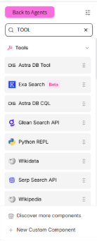

**What is the Agent component and how does it connect to TOOL?**

A component that performs connection to LLM, through which you can choose the desired model, and add the prompt according to which the model will work. Through this component, it's possible to connect the Tools to Flows using curly brackets { }, every time we write curly brackets we open an additional connection to a TOOL that will connect to the component. It's possible to open many connections to TOOLS.

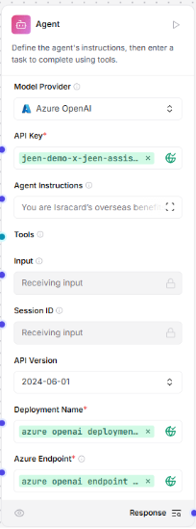

**Examples of common TOOLs:**

**Python REPL Tool**

A TOOL where the user writes a prompt and accordingly the TOOL creates Python code, runs it, and returns an answer accordingly.

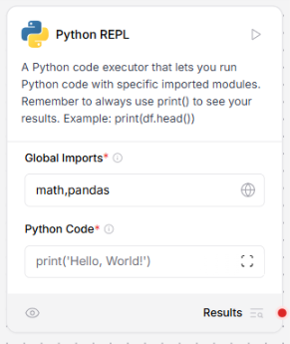

**PG SQL Query Tool**

A TOOL that performs connection to an external database of PostgreSQL type, through which it enables executing queries to the database. *Must attach the URL of the database.

תמונה שמכילה טקסט, צילום מסך, תוכנה, מספר

תוכן בינה מלאכותית גנרטיבית עשוי להיות שגוי.